|  |
| --- |
| **WQD7006**  **Machine Learning for Data Science**  **Multi-Layer Perceptron** |

1. Look at the following, which is a presentation of one unit of artificial neuron

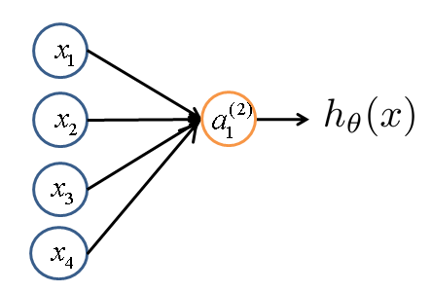

1. The node has four inputs  that receive only binary signals (either 0 or 1). Determine how many different input patterns this node can receive?
2. Consider the unit shown in Figure 1 below. Suppose that the weights corresponding to the four inputs have the following values:



and the activation of the unit is given by the step-function:



Note:  “Activation” of unit *i* in layer *j*

Calculate what will be the output value y of the unit for each of the following input patterns:

|  |  |  |  |
| --- | --- | --- | --- |
| Pattern, *Pi* | *P1* | *P2* | *P3* |
| *X1* | *1* | *0* | *1* |
| *X2* | *0* | *1* | *0* |
| *X3* | *0* | *1* | *1* |
| *X4* | *1* | *1* | *1* |

# Part 2

Use Iris dataset (WEKA) to answer the rest of the questions.

1. Run MLP using 50 trainings (epochs). Report classification performance.

1. Draw the graphical representation of the network.

1. Change the learning rate to 1. Run the classification and comment on the results.

1. Play with the number of hidden layers, from 0 to 3. Note the differences in terms of performance (GUI- False)
2. Change hidden layer to 5, set to training instead of cross validation. Comment on result

